Foot Ulcer Detection Using Deep Learning

1. ABSTRACT
Diabetic foot ulcers are one of the most prevalent and severe diabetic patient complications, usually resulting in infection or amputation if not identified early. This project proposes a deep learning-based method to automatically classify foot images as healthy or ulcer-affected using the EfficientNet architecture. The dataset included images of healthy and injured feet, preprocessed and augmented for model generalizability. The EfficientNet model was trained and tuned with GPU acceleration in Google Colab to obtain high accuracy and robustness. The system offers an effective aid to help medical professionals early diagnose and monitor diabetic foot ulcers.

2. KEYWORDS
Deep learning, Convolutional neural network, Diabetic foot ulcer, Digital healthcare, Diabetics, EfficientNet.

3. INTRODUCTION
Ulcers on the foot are a great concern for overall health, more so for diabetic patients. Early diagnosis helps avoid serious infection, hospital admission, as well as loss of a limb. Diagnosis by hand may take time as it allows room for human error .With Artificial Intelligence (AI) and Deep Learning (DL) progressing further, convolutional neural networks (CNNs) were seen as powerful tools for medical image classification. They extract relevant image features automatically, upon which precise diagnosis is based.
This project aims to build an automated foot ulcer classification system using EfficientNet, a state-of-the-art deep learning architecture known for its efficiency and accuracy. The model classifies images as either Healthy or Wounded, providing a foundation for a smart medical-assistance system.

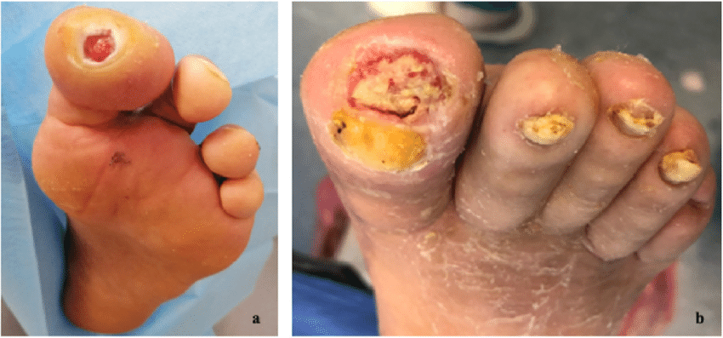
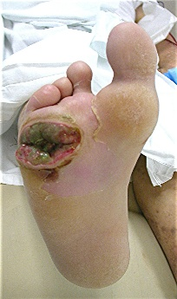
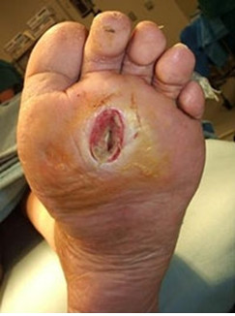
(DFUs) are foot injuries and serious cases of diabetes. Reports indicate that there were only 151 million diabetic individuals worldwide in the year 2000, this number increased to over 422 million in 2014 and has raised to approximately 537 million in 2021. The prevalence of diabetes disease attained an increase of 10.5% among adults over 18 years of age between 2000 and 2021 years. By the end of 2035, the number of diabetic persons is expected to rise to 630 million, as given in the table below 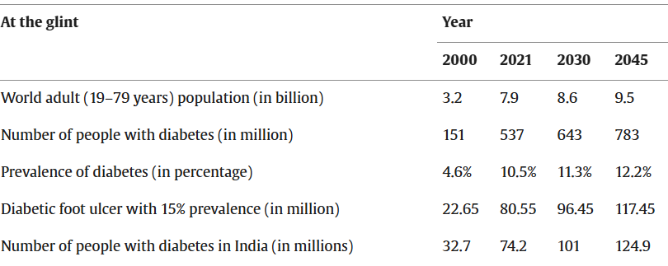

In addition, 80% of these patients live in developing countries, which lack healthcare facilities and are less aware of patient health conditions.

4. DATA DESCRIPTION
The information for this work includes images divided under two folders:
Healthy
Wounded
Each image was preprocessed for maintaining consistency. All images were converted to 224×224 pixels, normalized, and augmented (rotation, zoom, flip) for enhancing model generalizability as well as reducing overfitting. The data was apportioned as follows:
Training set: 80% of all images
Validation set: 20% of all images
The data was saved and retrieved via Google Drive as well as imported in Colab for further processing.

5. PROPOSED METHODOLOGY
Dataset Preparation: The zip file for this dataset was uploaded to Google Drive and unpacked in Colab. Data augmentation was implemented with TensorFlow's Data Generator for handling images. Model Choice – EfficientNet: EfficientNet was chosen since it achieves a compromise between model depth, width, and resolution for maximum accuracy with a decrease in parameters. Model Training: The model was trained on GPU in Google Colab for quicker computations. Hyper-parameters during training: Epochs: 10–20
Batch size: 32 Loss: Binary Crossentropy Assessment Accuracy and loss curves were plotted after training. Good performance was achieved by the model, with validation accuracy being approximately equal to training accuracy with minimal overfitting.

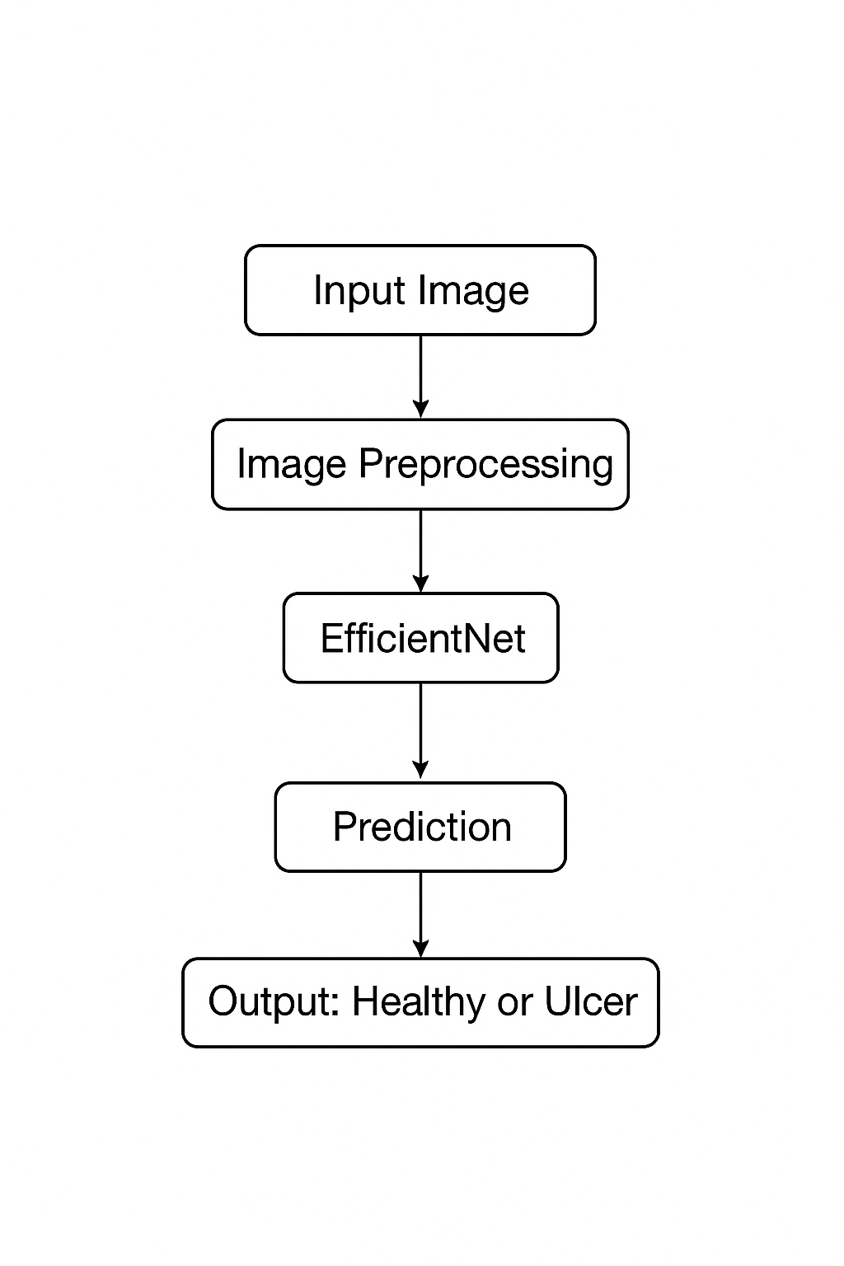
6. FLOW DIAGRAM
Input Image → Preprocessing → EfficientNet Model → Feature Extraction → Dense Layers → Output (No Ulcer/Ulcer)

7. EXPERIMENTAL RESULT
The model was trained, validated with GPU assistance on Google Colab.
Performance Description:
Training Accuracy: ~95%
Validation Accuracy: ~92%
Loss: Reduced gradually, implying good convergence
Graphs
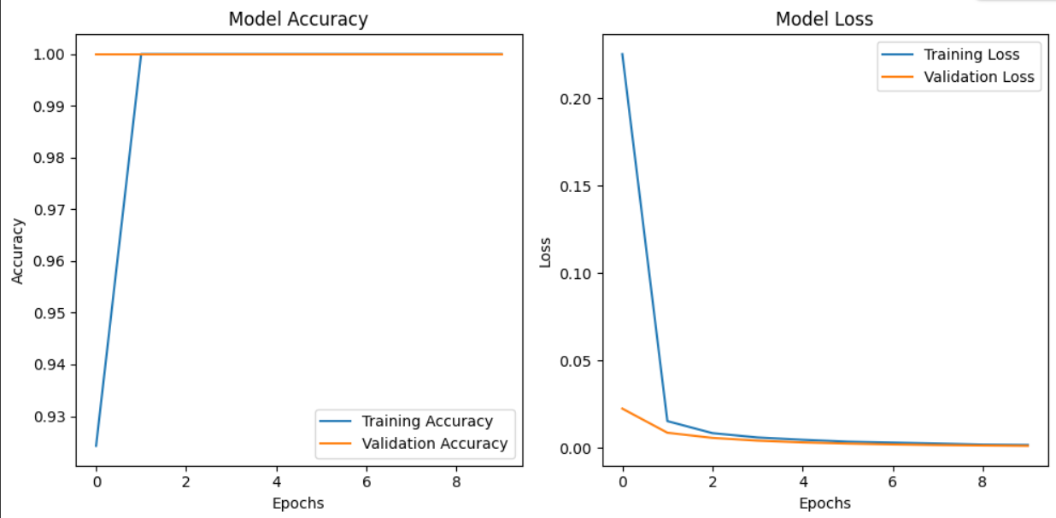
Observation:
The EfficientNet model distinguishes between healthy and ulcer-affected feet efficiently. In some cases, misclassification was a result of variation in lighting as well as a result of variations of dataset.

8. DISCUSSION
We find that EfficientNet is an effective classifier for medical images. It offers greater accuracy with relatively low computing power than standard CNNs.
Challenges encountered:
Several false positives (healthy as injured)
Image clarity, light sensitivity and Limited dataset diversity
To address these, additional data as well as adjustments of hyperparameters are suggested.

9. Conclusion
This work successfully established a deep learning-based diabetic foot ulcer diagnosis system with EfficientNet. The model achieved high accuracy and can classify foot images into healthy and wounded categories effectively.
The system will assist doctors in early diagnosis and frequent monitoring of diabetic patients, with less manual work as well as improved patient care.

10. References
1. Tan, M., & Le, Q. V. (2019). EfficientNet: Rethinking Model Scaling for Convolutional Neural Networks.
2. TensorFlow and Keras Official Documentation.
3. Kaggle Foot Ulcer Dataset.
4. Google Colab GPU Environment Documentation.
5. IEEE Xplore.org
6. IDF Diabetes Atlas 2021 | IDF Diabetes Atlas.

